D26: Seal sample change announcement
On , Road Management and construction JSC (ROMACO 26) announced the Seal sample change as follows:
Name of enterprise: Road Management and construction JSC (ROMACO 26)
Business code: 6000234922
Head Office: 387 Pham Van Dong Road, Buon Ma Thuot, Daklak Province
We would like to inform the change of seal/ stamp sample, as follows:
Sample of old seal/ stamp | Sample of new seal/ stamp | Remark
The old seal collected by Daklak Public Security | 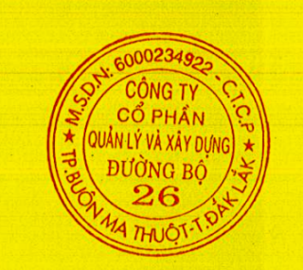

The effective date of new seal/ stamp: since July 27, 2017
Romaco 26 sends this notification to the Authority and enterprises to enable the business and cooperation.

